Step 1 — Create Database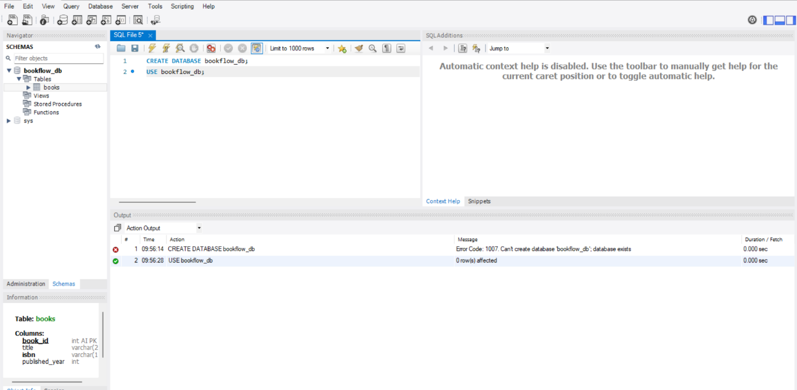Step 2 — Create Books Table (DDL + Constraints) 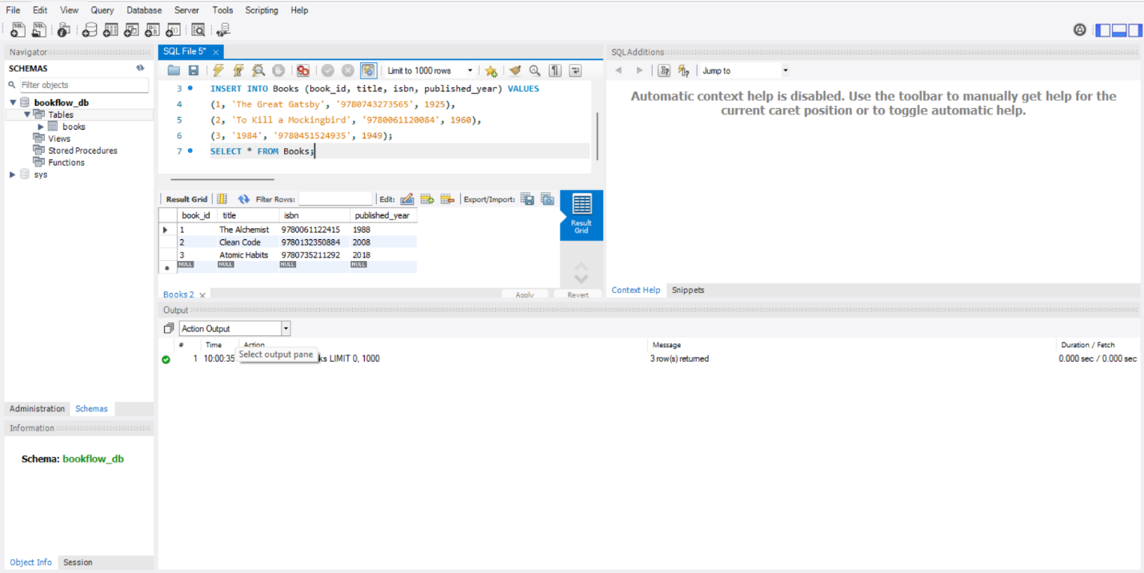
Step 3 & 4 — Insert Books and Display 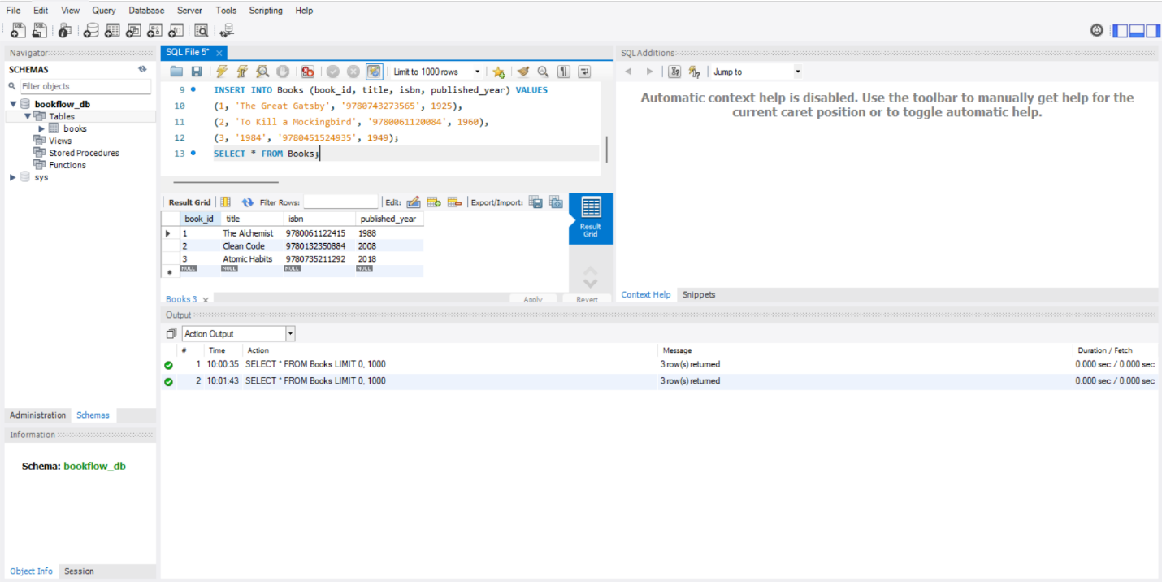Step 5, 6 & 7 — Members Table: Create, Insert, Display 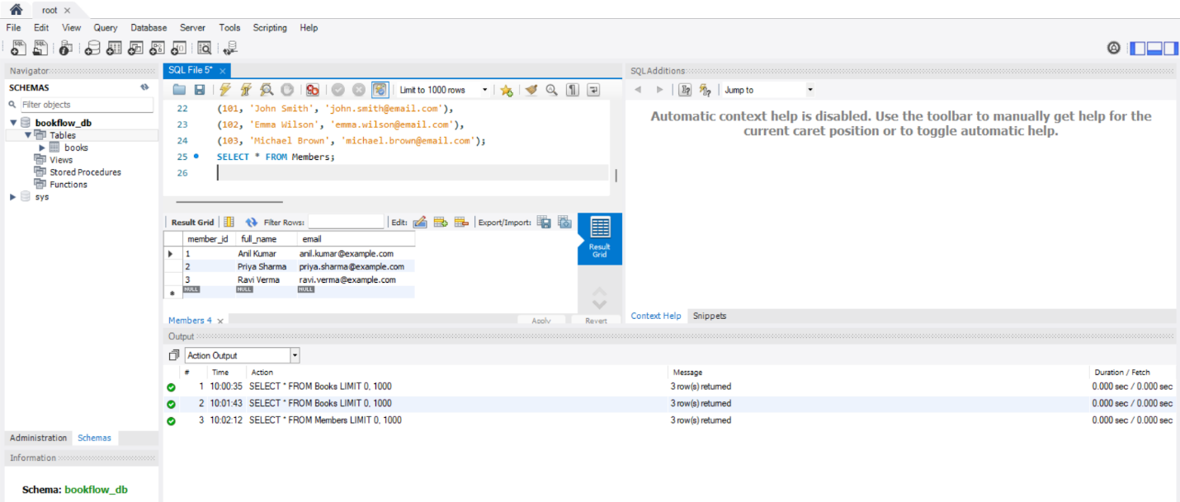
Step 8 — Create Loans Table (FOREIGN KEYS) 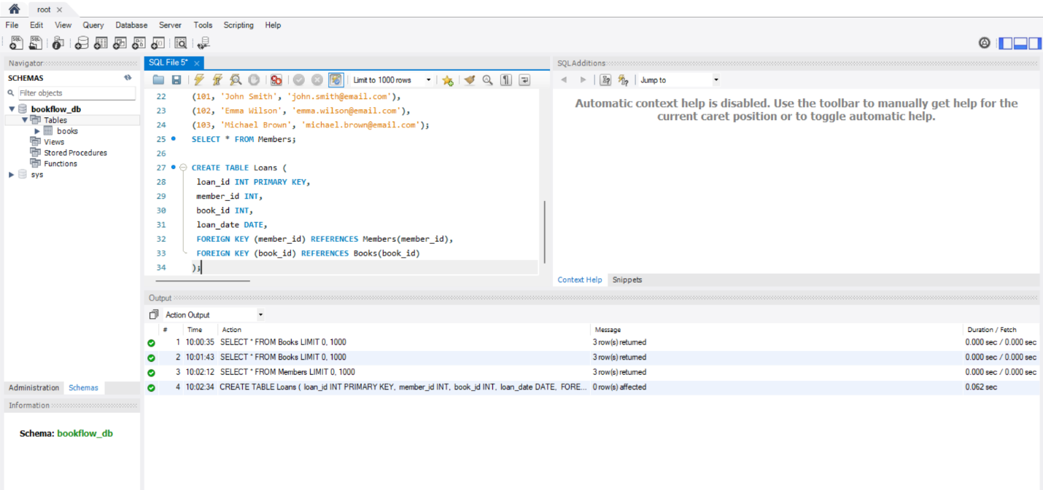Step 9 & 10 — Insert 10 Loans and Display 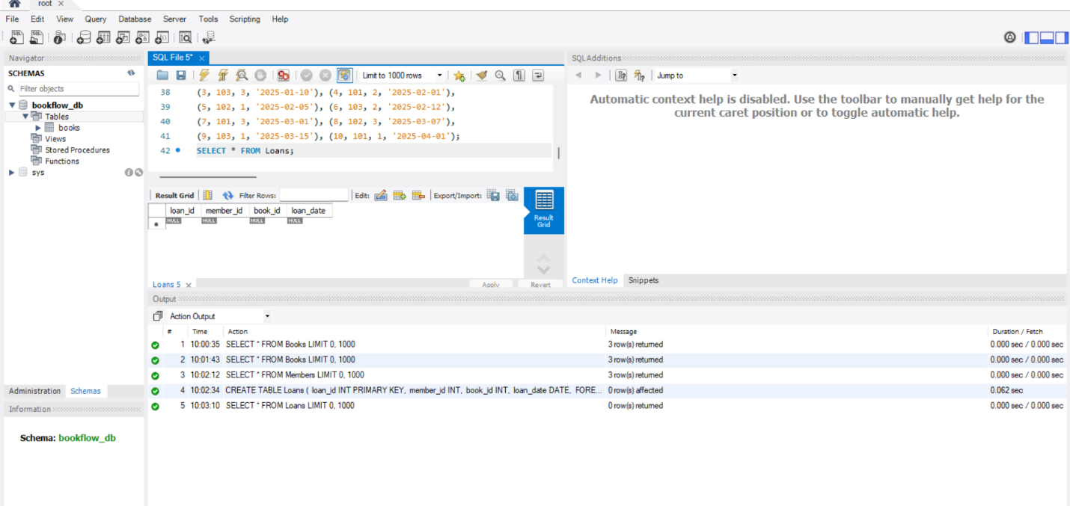
Step 11 — JOIN Query (Who Borrowed What) 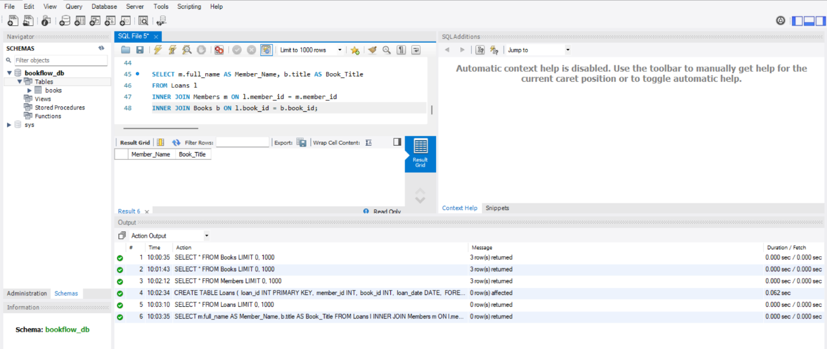Step 12 — GROUP BY Query (Books per Year) 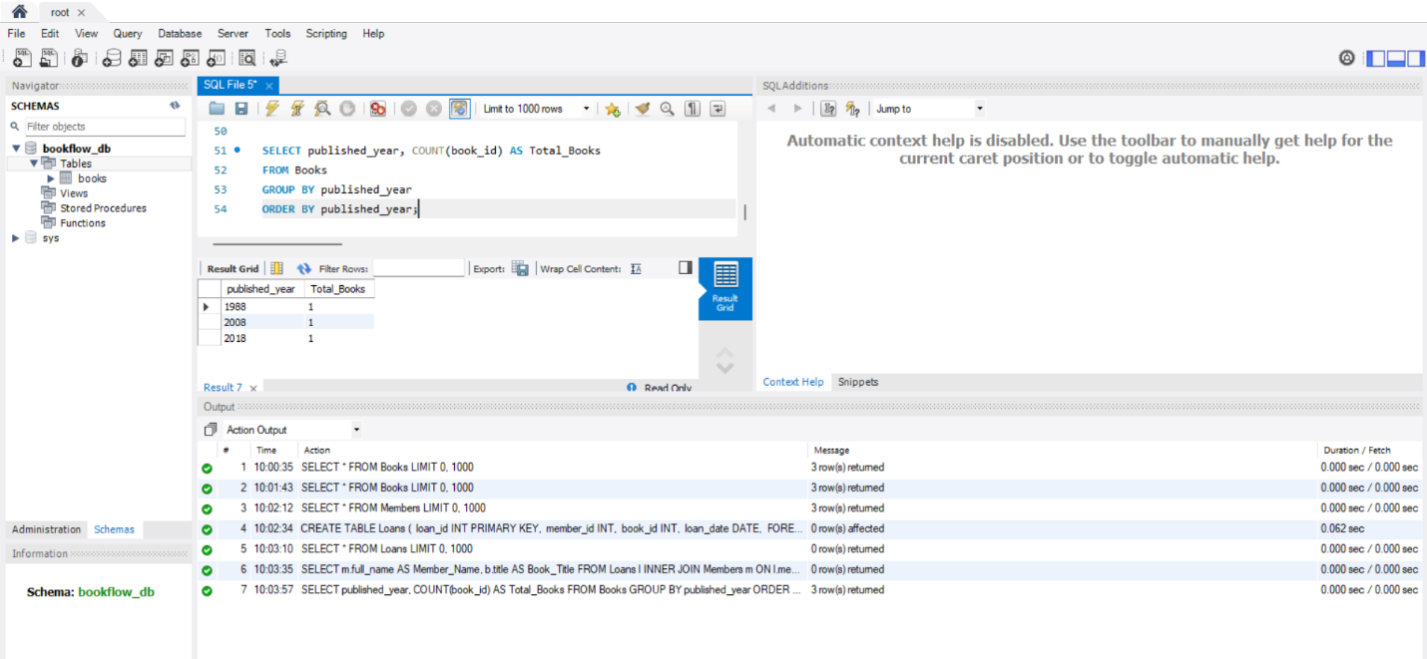
Step 17 & 18 — Index on ISBN + Fast Search 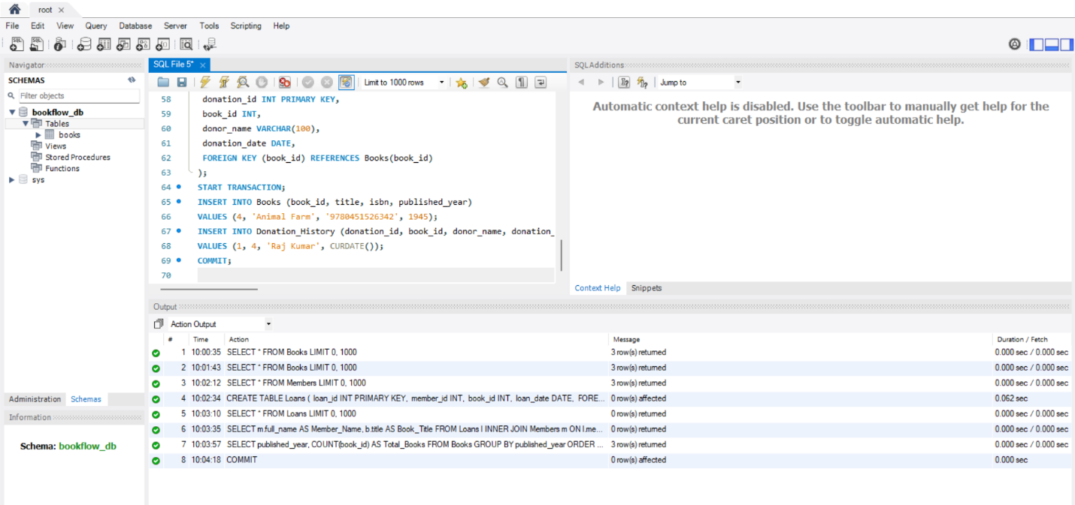Step 17 & 18 — Index on ISBN + Fast Search 